Budapest, April 24, 2013 – For the first time in Hungary, an international conference on seismic base isolation was held at the National Innovation Office (NIO) on the 24th of April 2013. Along with more than 90 participants, a Chinese delegation, led by professor Fu Lin Zhou and Mr. Ning Xiang Liang, CEO of the Zhuzhou Times New Material Technology, attended the workshop.
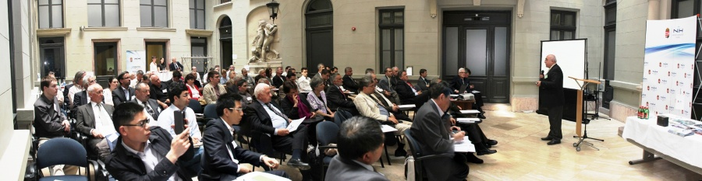
The company plans to launch a seismic safety construction technology developed with Hungarian professor Dr. Emanuel Csorba, on the European and Middle-Eastern market, as well as to create, in the near future a Central European Centre in Hungary.
The National Innovation Office, as the governmental body responsible for research, development and technological innovation, has set as its main objective to raise awareness, create and support developed innovation technologies and procedures in Hungary. This is why the NIO undertook to host the international seismic base isolation conference, and supported the international introduction of the new world-class Chinese seismic base isolation technology based on a Hungarian intellectual treasure of knowledge.
“The National Innovation Office is determined to promote and help the European and Middle-Eastern transfer of high-technologies, especially if Hungarian intellectual capital contributes significantly to their development. In addition, the NIO strongly supports the Chinese partner in establishing a Centre in Hungary, since this would significantly increase the domestic RDI’s international rank in the field of seismology.”, said Dr. Csaba Deák, the NIO’s vice president for strategy.
For over three decades the base isolation or seismic safety technology has been developing more and more. The first implementation of base isolated technology was in 1986 in the Unites States. East of downtown Los Angeles, the $30 million Foothill Communities Law and Justice Centre was built with 96 base isolators. Using this technology houses, public and office buildings, numerous industrial facilities, nuclear power plants, marine and river bridges have been since built not only in America but all over the world (New-Zealand, Indonesia, China etc.). Only in China, the subsequent incorporation of this earthquake safety technology is planned in almost one million existing school buildings.
It is well known that the southern and south-eastern parts of Europe, the Balkans and the Arab Gulf countries, and a number of Middle Eastern countries are regularly exposed to earthquakes. The Zhuzhou Times New Technology Company addresses this market opportunity by the creation of a Central European Centre.
Zhuzhou Times New Material Technology CO., LTD. (TMT), founded as Zhuzhou Time Rubber Industry Co., LTD in 1984 and renamed in 2001, is a subsidiary of the Zhuhou Eletric Locomotive Research Institute Co., Ltd.. Registered in 2002 at the Shanghai Stock Exchange (SSE), by 2010 the registered capital of the company was of 23 billion Chinese yuan. Zhuzhou Times New Material Tech is a company that is highly engaged in research and technology, has won multiple award wining, is environmentally conscious, and develops unique technologies. Thanks to its seismic base isolation technology, buildings with this system are resistant to earthquakes of a magnitude of 8 or 9 Richter. The technique has been successfully used in many construction projects, including a number of government buildings, bridges and railways.
Researchers and experts in industrial construction technology from Hungary, China, Turkey, Syria and Romania gave outstanding presentations, and among the more than 90 participants at the international conference people from Iran and Bosnia-Hercegovina were also interested in the event. At the conference, the Chinese experts met with the experts of the concerned territories, and after consultation they familiarized themselves with their seismological characteristics, as well as they got to know the relevant markets and the potential Hungarian partners.
More information: Balázs Szelei / balazs.szelei@nih.gov.hu / +36 30 663 2228
Presentations are available:
- Dr. Csaba Csaba: Opening Statement PDF (22 KB)
- Prof. Dr. Emánuel Csorba: Background informations by the Moderator PDF (7 423 KB)
- Péter Tildy: A brief overview of the Seismicity and earthquake hazard of Europe and the Middle East PFD (7 203 KB)
- Dr. Katona János Tamás: Evaluation and upgrading of the seismic safety of Paks NPP PDF (18 155 KB)
- Aybars Gürpinar, PhD.: Saving Nuclear Power Plants from Earthquakes PDF (2 313 KB)
- Dr. Ing Csaba Kegyes, Dr. Ing. Zsongor F. Gobesz: Design and Building Practice, Anti-Seismic Building Codes in Central European Carpathian Region, Hungary and Romania PDF (4 358 KB)
- Prof. Dr. Ing. Ramez Raslan: Building Industry and Earthquake Damage in the Arab region PDF (11 493 KB)
- Prof. Fu Lin Zhou: Application of Seismic Isolation in China PDF (50 157 KB)
- Dr. Ning Xiang Liang: Manufacturing and Application of Anti-Vibration and Seismic Products in the Engineering Field PDF (10 235 KB)
Seismic Base Isolation Workshop | Seismic Base Isolation Workshop
Seismic Base Isolation Workshop | Seismic Base Isolation Workshop
Seismic Base Isolation Workshop | Seismic Base Isolation Workshop
Dr. Deák Csaba (NIH), Prof. Dr. Csorba Emánuel | Aybars Gürpinar, PhD.
Seismic Base Isolation Workshop | Seismic Base Isolation Workshop
Dr. Deák Csaba (NIH) | Prof. Dr. Csorba Emánuel
Tildy Péter (MFGI) | Dr. Katona Tamás János (MVM)
Prof. Dr. Csorba Emánuel, Aybars Gürpinar, PhD. | Dr. Ing. Gobesz F. Zsongor
Professzor Dr. Ing. Ramez Raslan (CEC) | Professor Fu Lin Zhou (CAE)
Dr. Ning Xiang Liang (ZTNMT) | Seismic Base Isolation Workshop

